Anthony Redamonti

Syracuse university

Project 4

CSE 681 Software modeling & analysis

prof. gregory wagner

9/9/2022

Introduction

The following project was written in C# targeting the .NET6 framework in Visual Studio 2022 IDE. The goal of the project is to send *REST get* requests to a collection of https addresses to collect JSON data. The data is converted to JSON object form and displayed to the GUI as team name and the record for the 2020 season. Below is a class flowchart. Please download the Newtonsoft.Json package. In Visual Studio, click Project > Manage NuGet Packages. Search for “json.” The list of packages should include “Newtonsoft.Json” by James Newton-King.

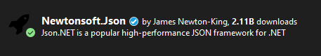

Class Flowchart of the TestFunctionality Class:

TestFunctionality

WebClient

SeasonInfo

Utility

GameInfo

VisTeamStats

HomeTeamStats

Class Flowchart of the MainWindow Class:

MainWindow

TestFunctionality

Project 4: System Flowchart

Response: JSON data (string)

TestFunctionality https://sports.snoozle.net/...teamName=1 Internet

Class Request Response  
 JSON data (string)

Background   
Thread Accesses Queue

MainWindow Class

API for online web server connected to a database.

Data is displayed  
on GUI

GUI is updated

Project 4: System Behavior

Project 4 contains the classes TestFunctionality and MainWindow inside its namespace. NflData.cs contains the contents from Project 2 (TestFunctionality class, etc.). The MainWindow.xaml.cs code composes an instance of the TestFunctionality class and displays its JSON object data to the GUI.

1. The MainWindow class composes an instance of the TestFunctionality class. It has access to the object’s queue of NFL team data. The MainWindow thread starts a background thread to start collecting JSON data for each NFL team.
2. The testFunctionalityObj sends a series of REST get requests targeting the API of an online server using a specific https address and deserializes a series of JSON objects inside a queue in the form of a SeasonInfo object.
3. After a team’s JSON data is enqueued, the background thread notifies the MainWindow thread that there is data ready to be displayed.
4. The MainWindow thread will dequeue the JSON data for that team and display it to the console.
5. After the JSON data of all 32 teams has been displayed to the GUI, the program exits.

GUI Design & Interaction:

The following GUI was created using a XAML C# project.

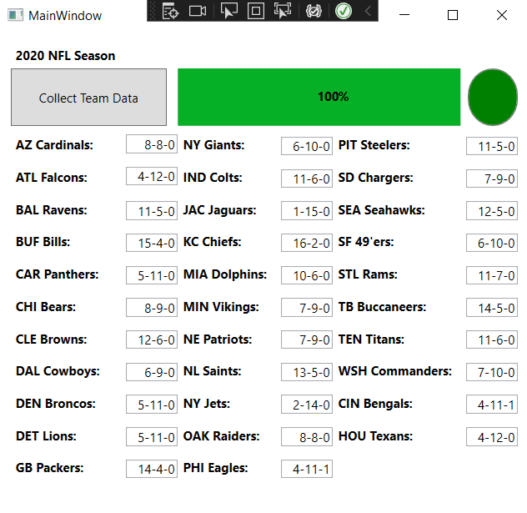

1. The user presses the “Collect Team Data” button. The progress bar is reset to 0%, and the circular status button turns red, indicating that the program is running.
2. The button event handler will start the background thread to begin collecting data. Every time a team’s JSON data has been collected, the background thread will notify the MainWindow class.
3. The MainWindow class will update the GUI with the team’s record for the 2020 season by accessing the JSON data in a queue of SeasonInfo objects stored in the instance of the TestFunctionality class.
4. When all 32 teams’ JSON data has been collected and displayed, the circular status button’s background color will turn green, indicating that the program completed successfully.

Code

The code comprising the project 4 namespace is distributed in three files: NflData.cs, MainWindow.xaml, and MainWindow.xaml.cs. The files are attached to the project submission.